Configuration files
There are 2 approaches:
- Make changes to DEV and test for DEV and then rework on changes in DEV for Production.
Note:
- Beginner level
- Use this for Payment related changes

- Make changes to DEV for PRD and test
Note:
- Expert level
- Use this for visibility related changes
Configuration files changes for DEV, QA and PRD in Public project:
- Always download the latest config files for DEV, QA and PRD and save it locally before making any changes.
Go to se80 tcode > MIME Repository > SAP >Public >BC >UI2 > ZMobius_logon >Custom >Config.json
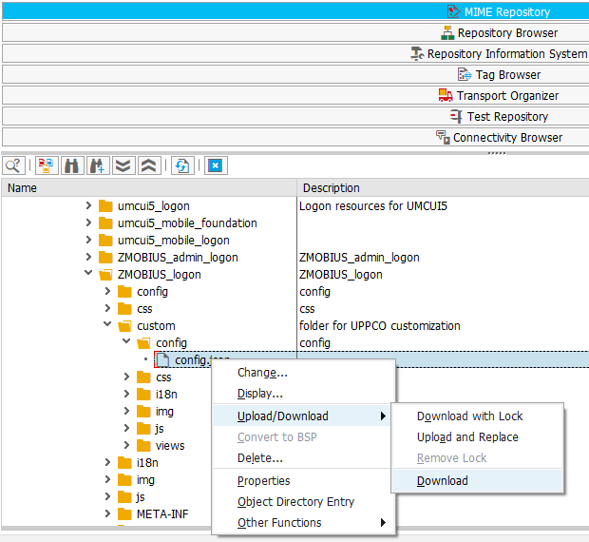

- Make a copy of DEV config file and make changes to the code for Productive use.
- Upload and replace the DEV config file to GWD and capture TR
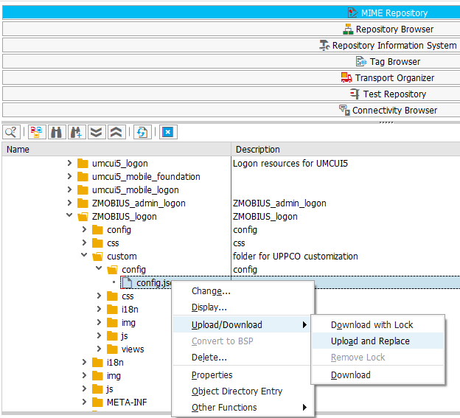

- Perform unit testing in DEV
- Release TR after testing
- Test the TR in QA
- Release the TR to PRD
- Make changes to DEV config file for QA use
- Move TR to QA
- Make changes in DEV config file for DEV use

Configuration files changes for DEV, QA and PRD in Private project:
- Pull latest code from ABAP server for DEV, QA and PRD.
- Make a copy of DEV, QA and PRD config files locally
- Make changes to DEV config file in Eclipse for PRD and create TR
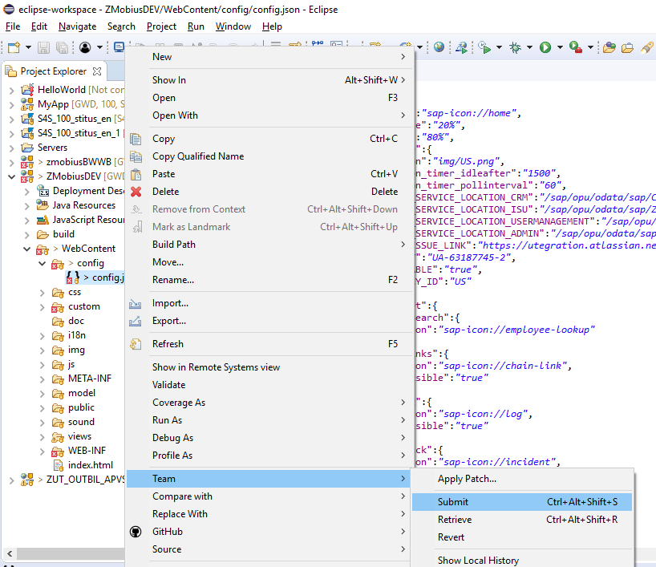

- Release the TR
- Perform unit testing in DEV

Below highlighted values differ for all environments:
- UPPCO
Private project-
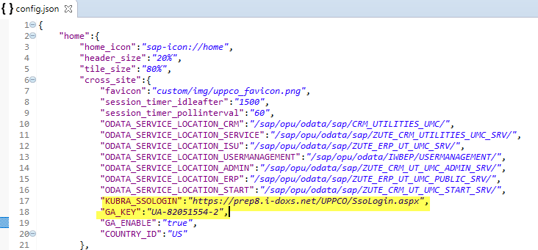
Public project-

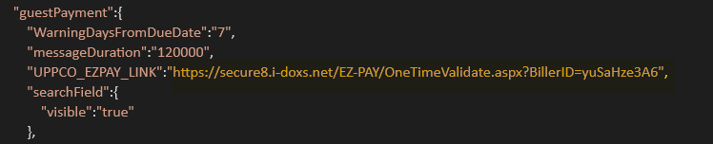

- BWWB
Private project-

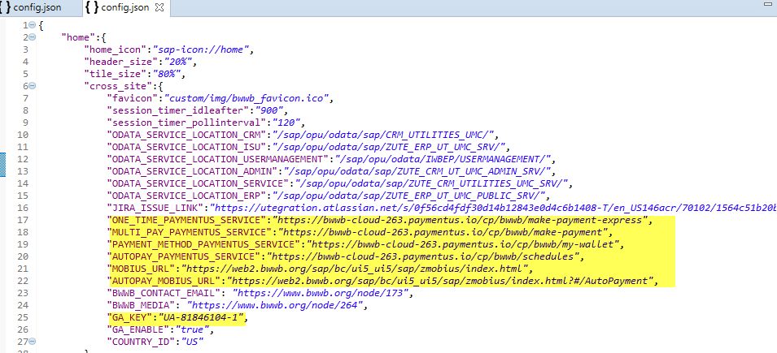

Public project-

